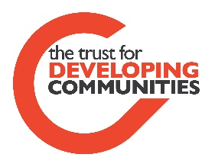
TDC Group Support Request Form

Application Date: Signature:

We will aim to respond to your request of support within 2 weeks of the date of your application.

Contact Name and what is your Role in the Group: | Group Name:
Where is your group based: | Group Contact:
Tell us about the support your group needs: Max 100 words

Examples might be: fundraising, committee or volunteer support or help with building your groups aims, objectives or community spaces.
- This support may be referred to other partner organisations with the right skills and resource to help you.

- We will prioritise targeted and tailored support based on current need with clear agreed outcomes and a specified amount of time to reach those goals.

- Priorities will be given to groups at risk, which cater to Community of identity who are experiencing barriers to engagement. These include children, young people and families groups, BME networks and groups which connect to chronically excluded individuals or Communities.
Please use the space below for any other Information you think may be useful:
Any information you share with us, will be safely stored as per General Data protection Regulation 2018 (GDPR), and will not be shared without your consent. If we think another Organisation is better suited to help you with your support needs, we will ask you for your permission to share this information with those partner providers.
If you need some support to fill in the form or would like to speak to someone about your needs before filling it in, please contact:
The Trust For Developing Communities on 01273 234769 we are based at Community Base, 113 Queens Road, Brighton, BN1 3XG
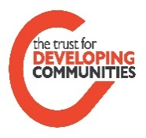
P&P The Trust for Developing Communities is a Company Limited by Guarantee registration number 3939332 and a registered Charity number 1106623 Community Development Training and support.

