
The Trust for Developing Communities

Youth Worker

Contents
Introduction…………………………………………………………………………………………………….. 2
Application Process …………………………………………………………………………………………. 3
Job Description ……………………………………………………………………………………………….. 4
Person Specification ………………………………………………………………………………………… 5
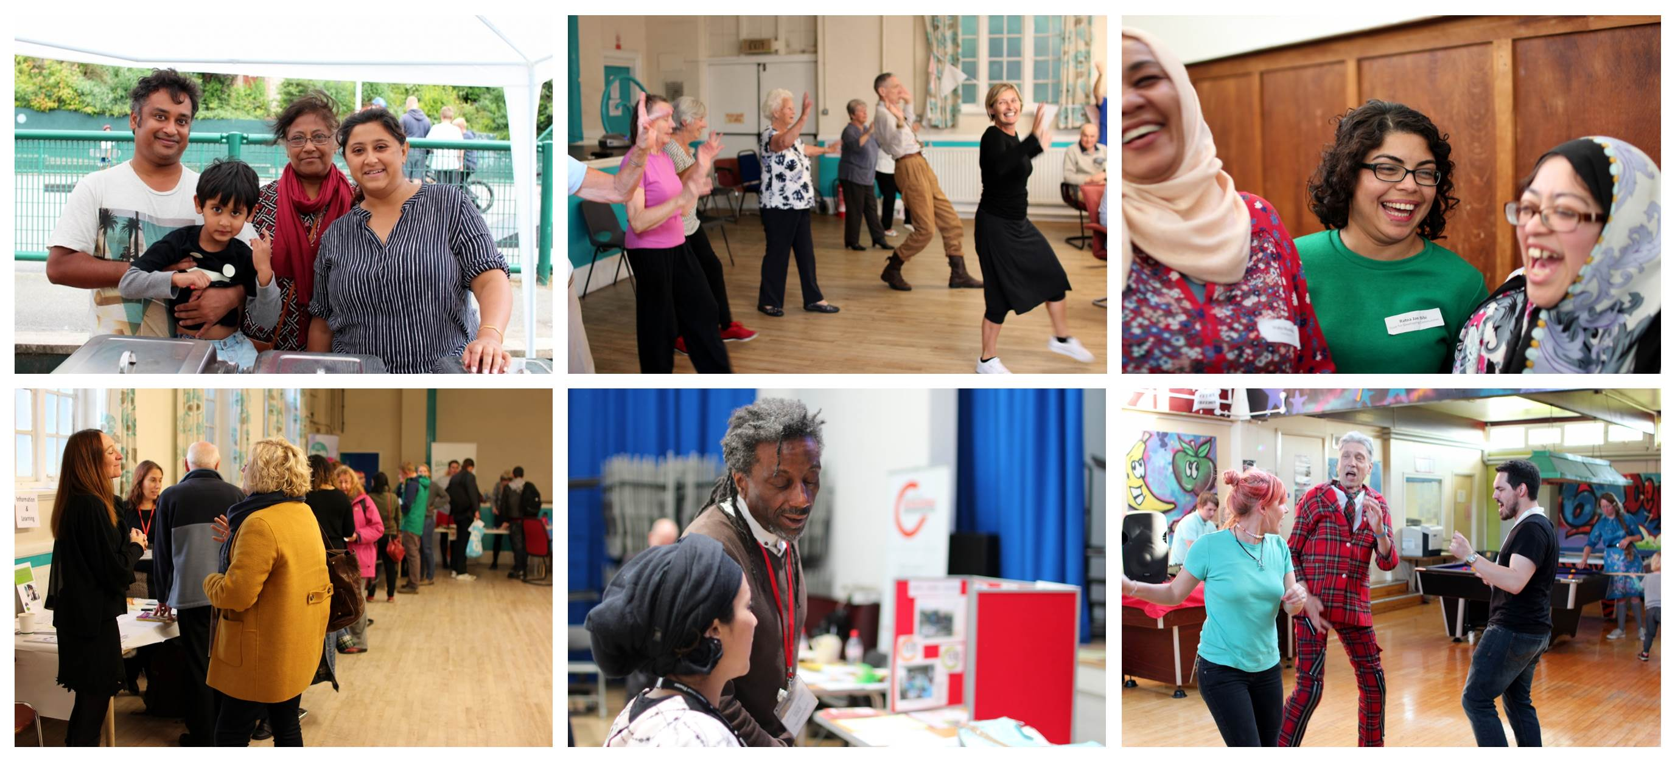
Introduction

For 15 years The Trust for Developing Communities (TDC) has been growing a style of youth work that puts young people at the heart of what we do and sees them achieve amazing things. We are seeking energetic, approachable and thoughtful people who use initiative and want to have a real, positive impact on someone’s teenage years.

The Role. Work involves being out in evenings mostly (when teenagers are about) and supporting them in youth clubs, arts and sports projects or on the street where we go into their spaces to build relationships. Through these relationships we support non-formal social learning where the curriculum is guided entirely by the needs that young people articulate. This role comes with the opportunity to be involved in new and impactful projects with some of the most in-need young people in the City.

About TDC. TDC is an independent charity with a proud 18-year track record of delivering community development work to empower communities in Brighton and Hove. We are a values driven organisation which believes in social justice, equality, community empowerment and collective action.

Our seemingly affluent city is home to some of the most deprived areas in England. We work with individuals and communities facing challenges, and offer support to address their specific needs and problems. We help groups with training, funding applications, governance and accessing services, so that people in our communities can take control of their own lives.

Our work includes significant local authority contracts to deliver community development directly in neighbourhoods across the city; youth work in two large delivery areas and citywide work to address inequalities with Black and Minority Ethnic communities and with older people.

Hours. The roles are required to work mainly on weekday evenings, when young people are socialising. Most sessions last approximately 3 hours, so a 9 hour post would involve working 3 evenings per week (or 2 evenings, plus some planning time in the day).

You will be joining TDC at an exciting time, working with an expanding youth work team who are actively seeking out new and innovative ways to meet young people’s needs that are also embedded in years of experience and learning around best practice.

Many thanks for taking the time to look into these roles - it is an exciting opportunity and we hope you will consider applying.
Athol Hallé, Chief Executive, The Trust for Developing Communities

Working Towards Equal Opportunities Registered Charity No. 1106623

Application Process

Please either email completed applications to: info@trustdevcom.org.uk or deliver to:

The Trust for Developing Communities,
Community Base,
113 Queens Road,
Brighton,
BN1 3XG.

Closing date for applications: Monday 2nd September 2019 at midday
Interviews will be held on either: Tuesday 10th or Wednesday 11th September 2019 at the TDC Head Office on Queens Road, Brighton. Please seek to keep at least one of these days free, we will discuss your preferences with you should you be invited to interview.

Due to time constraints, candidates will be informed as to whether they are to be invited to interview on or by Friday 6th September 2019 by 5pm.

Job Description

Job Overview
Job Title: Youth Worker – various roles available
Main Purpose: To plan and deliver youth work activities in line with the TDC’s Charitable aims
Rate of pay: £10 per hour
Hours: 9 - 18 hours per week
Contract: Fixed Term to end of October 2020
Reporting To: Area Youth Work Manager
Responsible For: None

Main Duties and Responsibilities

- To be responsible for planning and delivering activities for, and with, young people

- To provide administrative support to the Senior Youth Worker with and Youth Work Area Manager

- To build relationships with young people through a range of activities and to help young people build positive relationships with the wider community

- To offer informal advice and support to young people when required, bearing in mind the need to refer to specialist agencies whenever appropriate

- To be aware of relevant information and rights issues which affect the lives of young people

- To become familiar with the culture, the existing range of activities, networks, agencies, resources and demographic breakdown of the community in which they work

- To undertake regular monitoring and evaluation of work carried out and to assist the TDC in continual evaluation of its work, including the briefing and debriefing of sessions

- To assist with other monitoring activities, as appropriate.

- To adhere to the TDC’s Equality & Diversity Policy; all TDC staff are required to be active against prejudice.

- A positive attitude towards Equal Opportunities and Anti-Discrimination practice should permeate all aspects of the work

- To undertake all other reasonable tasks and responsibilities, as requested by the line manager

Person Specification

Essential Skills and Experience

- Youth Work - Experience of youth related work

- Communication - Ability to communicate effectively with young people and with all sections of the local community, while helping young people appreciate their relationship and responsibilities to the wider community

- Youth-focussed - Commitment to meeting the needs of young people while working in a local community setting

- Reflective learner - Willingness to learn from practice, as part of the supervision process, and through appropriate training

- Fairness - A strong commitment to Equal Opportunities and expression of this through practice

- Flexibility - Ability to work multiple evenings a week, occasional weekends, and in a variety of settings (on the streets, parks, community centres, young people’s homes, etc.)

- Positivity - Ability to bring a positive and enthusiastic approach to the work, and to motivate others

- Initiative - The ability to work on own initiative and manage own workload

Desirable Skills and Experience
- Qualification - in youth or community work

- Community Development - An understanding of community development work, its aims and methodologies

- Additional Skills - skills in arts, sports or other recreational activities

- Administration - Computer literacy, including the use of word processing, spreadsheets and email

The Trust for Developing Communities
Community Base, 113 Queens Road, Brighton, BN1 3XG
01273 234 769
info@trustdevcom.org.uk
www.trustdevcom.org.uk

Company Limited by Guarantee Registration Number: 3939332
Registered Charity Number: 1106623

