
The Trust for Developing Communities
Job Application Pack
Community Development Worker
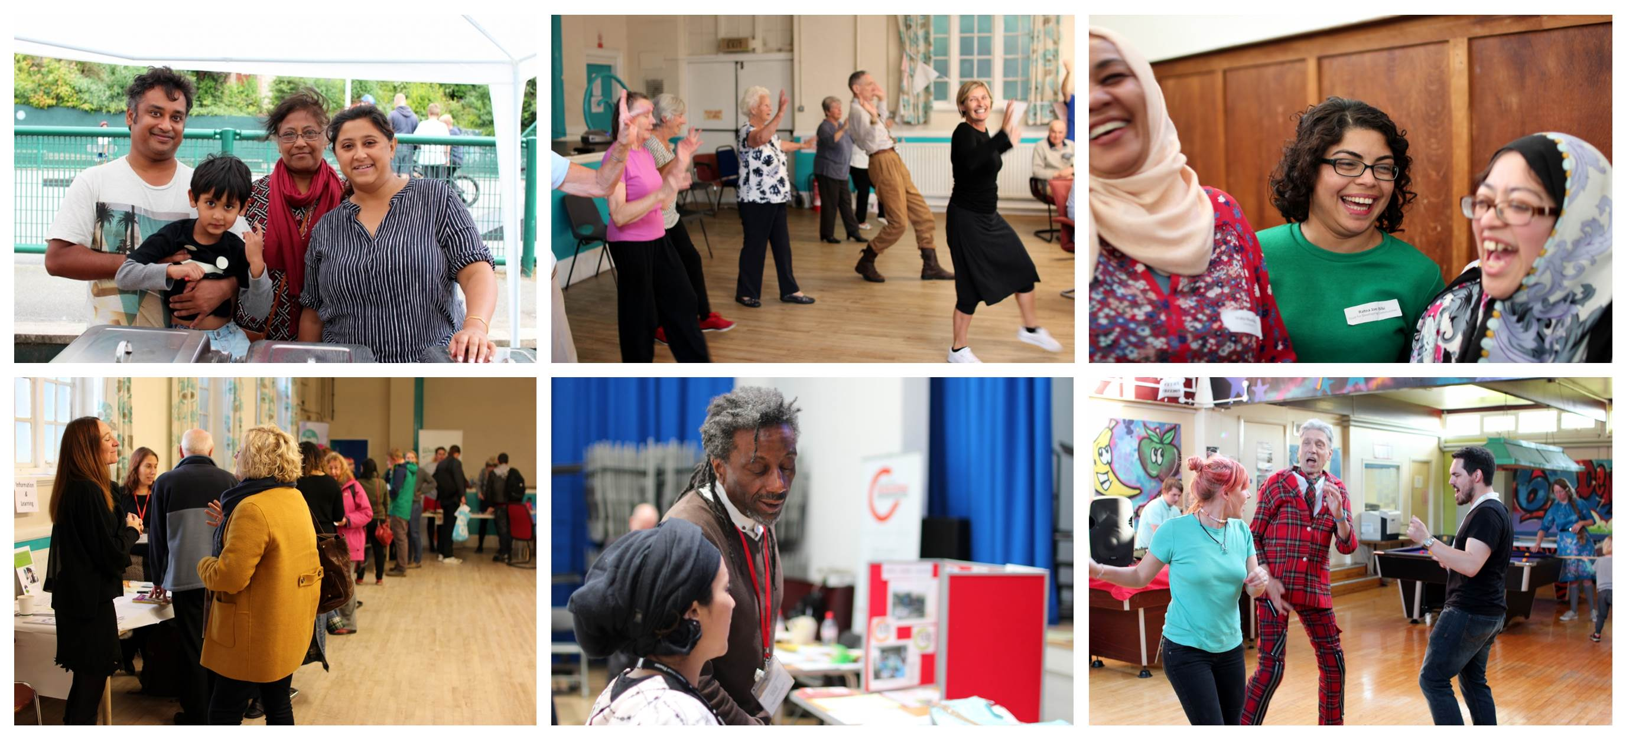
Part-time – Fixed Term Contract (Maternity Cover)

Contents
Introduction…………………………………………………………………………………………………….. 2
Application Process …………………………………………………………………………………………. 3
Job Description ……………………………………………………………………………………………….. 4
Person Specification ………………………………………………………………………………………… 5
Introduction

The Trust for Developing Communities (TDC) is seeking a proactive, dynamic and values driven Community Development Worker to join our team. You will be based in a neighbourhood, working with local people to improve their community and will also contribute directly to citywide work to address inequalities.

Hours. The job is between 21 -28 hours per week, and can be delivered flexibly in response to community need. This role is initially a fixed term contract to the end of March 2019, however there may be the opportunity for the role to be ongoing.

The Role. As a Community Development Worker within our Neighbourhoods Team, your key responsibilities will include:

- Working with community groups; supporting new groups to form and existing groups to flourish.
- Fostering community leadership and supporting communities with priority setting, planning and delivering projects.
- Developing robust community assets, including advising on governance and fundraising.

You will be based mainly within a community centre in the City, with some responsibility for the management of your office. You will also attend staff meetings and training at our central office in Hove.

About TDC. TDC is an independent charity with a proud 18-year track record of delivering community development work to empower communities in Brighton and Hove. We are a values driven organisation which believes in social justice, equality, community empowerment and collective action.

Our seemingly affluent city is home to some of the most deprived areas in England. We work with individuals and communities facing challenges, and offer support to address their specific needs and problems. We help groups with training, funding applications, governance and accessing services, so that people in our communities can take control of their own lives.

Our work includes significant local authority contracts to deliver community development directly in neighbourhoods across the city; youth work in two large delivery areas and citywide work to address inequalities with Black and Minority Ethnic communities and with older people.

You will be joining TDC at an exciting time as we develop our new vision for achieving greater equality within our city and beyond.

Many thanks for taking the time to look into this role, we look forward to receiving your application.
Kirsty Walker

Projects Manager
The Trust for Developing Communities

Application Process

Application. To apply for this job. Please read the Guidance Notes for Applicants document and then submit a completed Application Form and also the Equal Opportunities Monitoring Form to info@trustdevcom.org.uk by 9.00am on Tuesday 3rd April, 2018.

The following documents are available to downloads on the TDC website at: www.trustdevcom.org.uk/get-involved/jobs
- Guidance Notes for Applicants
- Application Form
- Equal Opportunities Monitoring Form

Interviews. The interviews will be held on Monday 9th April, 2018 at Millwood Community Centre, Nelson Row, BN2 9QH.

We will aim to notify all candidates if you have been successfully shortlisted for an interview by 5pm on Wednesday 4th April.

Start Date. The successful candidate will ideally be able to start, or attend some handover meetings during April.

Enquiries. If you have any questions regarding the role, please contact TDC’s Neighbourhoods Projects Manager, Kirsty Walker on kirstywalker@trustdevcom.org.uk or 07939831160.

Job Description

Job Overview
Job Title: Community Development worker
Main Purpose: To build strong and inclusive communities through working with community members
and with groups.
Hours: 21-28 hours per week, to be agreed; must include Tuesday mornings.
Salary Scale: £23,398 to £28,485k pro-rata (NJC Scale points 26-32) + 6% pension. Pay Award pending.
Depending on experience.
Contract: Fixed Term to 31st March 2019
Holiday: 25 days a year, plus an extra 3 days at Christmas, pro rata, and all Bank Holidays.
Work Base: Neighbourhood Office in Brighton
Reporting To: Neighbourhoods Projects Manager.

Main Duties and Responsibilities
- To ensure that TDC’s commitment to a high quality community development approach is always paramount and TDC values are adhered to throughout the work.
- To work with communities to help them identify their assets and priorities through a variety of methods; including consultation exercises and asset mapping.
- To develop vehicles for community and service partnerships to deliver projects around those priorities.
- To support the growth and development of community groups delivering their own projects and services and foster community leadership.
- To work with neighbourhood organisations to address barriers to participation by communities of identity and interest.
- To prepare funding applications, where appropriate, and ensure where applications have been successful, that funds are used for the purposes outlined in the application.
- To offer support and supervision to TDC volunteers involved in projects you are leading on.
- To provide regular written reports, including monitoring data, for the Board of Trustees, funding agencies and other bodies as may be required.
- To operate within, and contribute to the development of, TDC’s established administrative and financial practices, taking responsibility for budgets and financial accountability, where delegated by your Line Manager.
10. To, implement and promote the TDC’s Equality & Diversity Policy. All staff are required to be active against prejudice from colleagues, community members and all others. A positive attitude towards equal opportunities and anti-discrimination practice permeates all aspects of TDC’s work.
Person Specification

Experience, Knowledge & Skills:

- Community Work. At least 2 years’ experience of community based work; ideally including some experience of lone working.
- Independence. Working independently; planning and delivering against own work plan.
- Fundraising. Experience of writing grant funding applications and providing monitoring for funders.
- Governance. Knowledge of governance and policy issues for community groups.
- Community Priorities. Skills in working with communities on setting priorities.
- Partnership Working. Experience of working in partnership with a range of agencies and professionals.
- Community Development. Demonstrable commitment to asset based community development principles and practice.

- Communications. Ability to present information clearly, to a high standard, both written and oral; including presenting to a public audience and using appropriate communication tools and media.

- Equal Opportunities. Good understanding and commitment to equal opportunities and experience of working with diverse communities, cultures and faiths.

The Trust for Developing Communities
Wavertree House, Somerhill Road, Hove BN3 1RN
01273 262 220
info@trustdevcom.org.uk
www.trustdevcom.org.uk

Company Limited by Guarantee Registration Number: 3939332
Registered Charity Number: 1106623

