[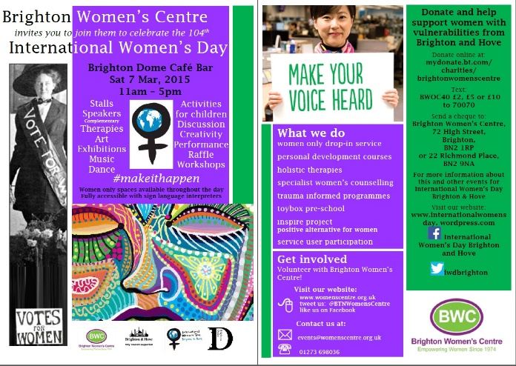](https://internationalwomensday.files.wordpress.com/2015/02/iwd-dome-flyer-20151.jpg)**Celebrate International Women’s Day 2015!**

**Empowering Women - Empowering Humanity: Picture It!**

International Women’s Day Brighton and Hove Brighton Women’s Centre celebrates [International Women’s Day](https://internationalwomensday.wordpress.com/2013/01/18/international-womens-day-2013-a-week-of-celebrations-in-brighton-hove/) on Saturday 7 March. This year the theme is **‘Make It Happen’** to encourage effective action for advancing and recognising women around the world.

Join governments and activists across the world in commemorating the 20th anniversary of the ground-breaking World Conference on Women and the landmark Beijing Declaration and Platform for Action.

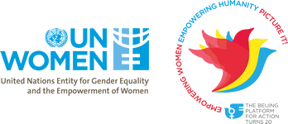

This links with the UN Women’s [Beijing+20 campaign](http://beijing20.unwomen.org/en/about) **“Empowering Women, Empowering Humanity: Picture it!”**  8th March is a celebration of the achievements that have come since then and galvanize action to address the gaps that still remain in making gender equality a reality.

Considered the most comprehensive blueprint on advancing women’s rights, the 1995 [Beijing Declaration and Platform for Action](http://beijing20.unwomen.org/~/media/field%20office%20beijing%20plus/attachments/beijingdeclarationandplatformforaction-en.pdf) was adopted by 189 governments. Even 20 years later, it remains a powerful source of guidance and inspiration. The Beijing Platform for Action focuses on 12 critical areas of concern, and envisions a world where each woman and girl can exercise her choices, such as

* participating in politics,
* getting an education,
* having an income,
* and living in societies free from violence and discrimination.

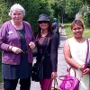**Empowering women: TDC’s community development approach**

TDC will be promoting International Women’s Day and encouraging the women’s groups we support to take part in the celebrations with women around the world.

Some of the women’s groups TDC works with include the Hollingbury Multicultural women’s group, supporting them to come together regularly after their English classes to take part in activities. They aim to build confidence by learning together through activities such as healthy eating workshops, yoga, health walks and IT skills. These activities support them to improve and practice their English and overcome isolation that they sometimes feel.



TDC has run and supported women to participate in assertiveness training for multicultural women’s groups.

Bevendean Young Women’s Group is a project that has involved anywhere between 10 and 25 young women weekly in fun activities relating to their identities and issues. They produce work annually that is submitted to the ‘B.Fest’ youth arts festival and generally have a great time! They have been focusing on mental health and wellbeing by doing art, photography and group discussions.

B.Fest: http://(instagram) bevendeanyoungwomensgroup

They also focus on film making, music making, recycled fashion, art and dance. These activities have enabled the young women to feel more confident and empowered.

See the youtube film with young women talking about their project for the Big Dish-Out participatory budgeting that they were successful in winning.

<http://www.trustdevcom.org.uk/wp-admin/admin-ajax.php?action=vscdoom&movie=http://www.youtube.com/watch?v=pQYdXfdy44o?rel=1>