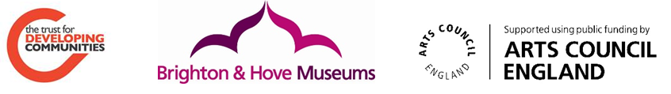

The Select Project: From Downs to Sea

Overview
This report is about a Community Curators project involving the residents of Portslade and West Hove from April 2013- June 2014. Royal Pavilion & Museums Brighton & Hove (RPM) initiated and secured funding for this project from Arts Council’s England. They worked in partnership with a local community development organisation, The Trust for Developing Communities (TDC). Together, we supported local people to come together through a series of meetings and events, to curate, interpret, present, engage audiences in and market an exhibition of modern and contemporary British art in prime gallery space in Brighton Museum. This report tells how residents became community curators to put the exhibition together, and what they and those visiting the exhibition thought about it.

The one year project from April 2013 to June 2014 involved the group coming together in the following ways:
- 12 Meetings - to come to consensus on the art to be displayed and the exhibition
- 5 Visits to other exhibitions to learn about display and interpretation
- 2 Creative sessions to develop their personal and local contribution to the exhibition
- 6 Filming sessions to make ‘Talking heads’ film to accompany the paintings
- Group members gave guided tours for visitors to the exhibition
- 2 major public events to accompany the exhibition
This project has been a great opportunity for collaborative work between RPM, TDC and residents, actively engaging with the community. Over the year, the connections developed and evolved, and the group grew into a strong, committed team. The group were given a very challenging and open brief to select an exhibition from the Arts Council Collection. This diverse group of people responded well to the challenges, negotiating the world of curation and worked as a group to create an exhibition that related to their own lives, between the Downs and the sea.

The process
In 2013 RPM submitted a proposal to the Arts Council Collection for a major exhibition in Spring 2014 as part of the Select programme. This is an innovative programme that invites museums to select exhibitions drawn from the Arts Council Collection. Select enables museums to make use of the largest national loan collection of modern and contemporary British art. This programme is part of the Arts Council’s commitment to providing access to one of the UK’s main national collections.

The project supported RPM’s core purpose to engage with audiences creatively and collaboratively, inspiring enjoyment, discovery and learning. RPM’s Forward Plan 2012-15 Towards 2020: Culture Connects, lays out in its vision: ‘RPM will be renowned for co-production and collaboration, and in reaching new and more diverse audiences and for inspiring a sense of shared ownership with its communities’.

RPM approached TDC to see if they would be interested in working on the exhibition as a communities’ project - working with groups from across a neighbourhood to select, create and install an exhibition of their choice with RPM’ s support. RPM commissioned TDC and we developed a project plan together. There were regular meetings throughout the project to plan and review together.

TDC did the early groundwork with its community networks and groups to see who would like to be involved. TDC advertised an introductory meeting, through social media, posters and newsletters, inviting interested residents and community groups to come to a meeting to talk about the project together with RPM and TDC staff. TDC’s community development worker and RPM community engagement worker organised and facilitated a series of meetings and events as detailed below:

Timeline of the process
At the first meeting TDC and RPM gave an overview of the project. The project would enable people from the Portslade and Portland Road neighbourhood to decide a theme or title for the exhibition and select pictures from the Arts Council Collection. RPM felt that a project connecting people who shared a bond due to their neighbourhood and locality would be a refreshing addition to the RPM’s programme. RPM’s Community Engagement strategy prioritises communities of place and communities of interest based on both RPM’s under-represented and excluded communities and on the ten neighbourhoods identified as city priorities based on statistical deprivation data from the city’s Community Development Commissioning Needs Assessment 2011

People would come together as a group to decide what they would like to do. Benefits of getting involved included
- developing skills in planning
- meeting new people
- raising awareness about making art more accessible
- exhibition design skills etc.
At this first meeting, the group had an opportunity to look through the Arts Council Collection catalogues and leaflets, to get a better idea of what art was held there. We also looked at earlier Select exhibitions. Themes could be whatever the group wanted to choose: work, life, feelings, emotions, family, seaside, history etc

The group discussed what art would be interesting and relevant to people that live in their neighbourhood. It was clear from the discussion that exhibitions and art inspired people's passions and ideas. We hoped to capture these in the project.

Some people expressed concern about being overwhelmed by the collection and not knowing what to choose. We talked about how the group would meet to decide on a theme that all agreed with and come up with a shortlist of art, by looking at the collection on line and in Arts Council Collection catalogues beforehand.

A second meeting in April was facilitated by TDC where the group came up with exhibition themes based on looking at the Arts Council Collection and thinking about the identity of the Portslade area. These were wide ranging and included:
- Coils
- people
- trees
- textures -bark
- black and white/ contrasts
- be surprised/ be amazed/ unpredictable/ take people unaware/ mix it up
- travel/ go places in the art
- colour/ space
- poets corner/ artists streets
- multiculturalism
- slice of life; industrial (Swedish timber to portslade link); the south downs; local shops and businesses, schools (Portland road); the sea, leisure fun, holiday
People voted on their favourite themes.

The third meeting in May was at Brighton Museum & Art Gallery where RPM staff took the group on a tour of the Jeff Koons exhibition to look at the exhibition galleries. It was great to see the three connecting rooms and get a feel for their size, space and lighting. The group started to discuss what might fit into the space and the visit got imaginations flowing, thinking about sculptures, wall colour, types of narrative, displays etc. The shortlisted themes were discussed again. There was much debate about semantics, ideas and styles preferred. Ultimately the group agreed on the working theme of:

Slice of Life- Downs, City, Sea

This title beautifully encompassed the smaller themes that the group hi-lighted in the previous meeting, including: diversity, the idea of journeys and being taken somewhere, of people and multi-culturalism, history, the urban & natural landscape and the sea. It was agreed that the themes of “Colour” and “Be surprised” were too broad in themselves but that elements could easily be reflected in the chosen theme. It was also clarified that a diversity of styles could fit into the agreed theme including abstract, landscape, sculpture, film and textiles.

The group were asked to create a Longlist from the Arts Council Collection before the next meeting. People found the Arts Council Collection website difficult to use as the only search available is by title or artist; RPM signposted the group to the “Your Painting” BBC website http://www.bbc.co.uk/arts/yourpaintings/ where they could search the collection by theme and there are more images, additionally it was suggested that if they had other specific artists or sculpture in mind to do a Google image search. RPM staff suggested that the group gather a long list of 30 pieces per person relating to the theme.

At the fourth meeting, individuals shared their chosen works from the Arts Council Collection, facilitated by TDC and RPM. These 115 images were then displayed on the walls at the fifth meeting. The group voted on a short list which was then submitted to the Arts Council Collection. The group successfully navigated a tricky process to find consensus.

The sixth meeting involved learning about interpretation methods with RPM staff, through a walkabout at Brighton Museum, including films, sound, smells and activities; and more traditional, with labels for each art work.

At the seventh meeting in September 2013, the group learnt they were unable to have all they had requested from the Arts Council Collection, as some work was unavailable, causing some disappointment. They were supported by RPM staff to think about using the 3 gallery spaces in different ways, with history books, images, comments board and sofas. RPM Digital officer talked about marketing, walking tours and a film.

In October 2013 the exhibition dates were confirmed: 4th April- 15th June 2014. In this eighth meeting, the group decided a title and description for RPM marketing material. The group developed and wrote a film brief for the “Talking-heads” film.
They then got together, supported by TDC and RPM, to plan the trip to the Victoria & Albert museum and visited the V&A in November 2013 and in December 2013 they visited the Turner exhibition at The Royal Pavilion. They discussed what they had learnt about interpretation from both these trips.
The two final meetings of the group involved creative sessions with an artist and film maker to generate images for the third gallery, using mapping and collage; and the talking-heads film. They agreed interpretation including their own photographs, poetry, history of buildings, and favourite artists that inspired them.
In January and February, the group were filmed talking about the project.
4 April 2014: Exhibition was launched with speeches by local Councillors along with many of the participants who were involved. The private view was very well-attended by members of the public. It was a very proud moment seeing the exhibition open, after all the hard work over the last 13 months.

Learning opportunities
RPM organised learning opportunities and creative sessions to support skills development, and enhance the exhibition and the group’s experience. These are outlined in more detail below.

Visiting exhibitions and learning about interpretation
Visits to exhibitions were facilitated by RPM staff, who chose a diverse selection of exhibitions and displays to explore; they guided and mentored the group through walking tours around the exhibitions, inviting them to consider the different methods of interpretation and display, posing questions that helped them decide what they wanted to use in their exhibition. An exhibition is not only about what is displayed – but also how it is displayed:
“Explanation … interpretation … clarity … lighting … – even seating …” (Adam, community curator)

They visited several other exhibitions, learning a lot about interpretation. Exhibitions included :
- Jeff Koons (how to exhibit – some work might be considered unsuitable)
- World Stories: Young Voices (Brighton Museum & Art Gallery)
- Catwalk to Club (Victoria & Albert Museum) (the importance of labels – for example brown text on orange card in dim lighting was difficult to read)
- Turner Exhibition (Royal Pavilion)
- Women Artists (Brighton Museum & Art Gallery)
Everyone agreed that this was something they enjoyed the most
“None of us will be able to go to an exhibition again and look at just what is on display!”

Creative Sessions
The group learnt about curation and worked together to create an exhibition that related to their own lives, between the Downs and the sea. In addition they did this through some very enjoyable creative days. They brought to the Museum their unique voices, experiences and priorities, including a strong focus on connecting and sharing. The group were given the opportunity to explore the idea of place and their local neighbourhood through collage and map making with local artist, Annis Joslin. The resulting work was used to create some framed collages and maps for inclusion in their exhibition.

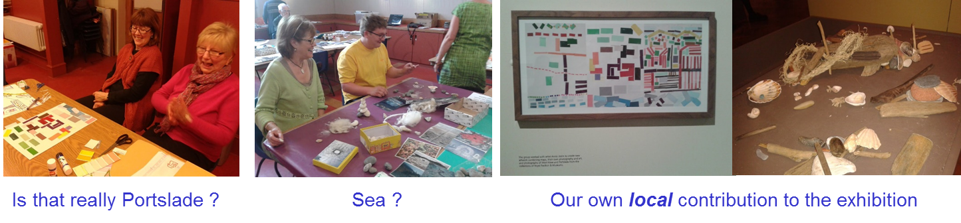

Talking Heads films
Film was chosen by the group as a medium to enhance the experience of the visitors: talking labels that are accessible to all. The group were captured on film by local film maker Alice Ross, talking about the pieces of art that inspired them and why they chose them. They were filmed at various locations in Portslade and West Hove, such as Mile Oak Farm, Portslade Community Allotment and Stoneham Park.

They talked about their experiences of life and the history and landscape of the area. The films really captured everyone’s individual journeys, as well as their reflections on the group process, the project as a whole and where they lived. The exhibition was powerfully put in the context and place of Portslade and West Hove.

See the films at https://www.youtube.com/watch?v=k5ZO6DEARtw
https://www.youtube.com/watch?v=jqvPAwC28UI

Interpretative events
RPM organised a Museums At Night event, “Paint it Late” which included the group members giving guided tours of the exhibition. It was a wonderful opportunity for members of the group to share their stories and for the public to meet the people behind the scenes, the voices and faces in the films.

A Family Activity day facilitated by RPM, provided Downs –City –Sea art and craft workshops which complimented the exhibition beautifully. Images of Andy Goldsworthy sculptures using natural materials and found objects from the Downs and the Beach were used to inspire sculpture and play. Pictures of Hundertwasser architecture were used to help people ‘re-design their street’ through multi-coloured collage.

Local artist, Laetitia Yhap, delivered two talks. This provided a lovely opportunity to hear directly from the artist about her work which the group had chosen to include in the exhibition, “Paul, Michael, Stephen and Tim in Summer”, a painting of a beach scene with fishermen on a circular piece of wood.

Evaluation Process
A key part of the project was its evaluation to ensure that participants’ views fed back into process and into future projects to enable greater accessibility of Museums by communities.

Evaluation by the exhibition visitors
The exhibition was well attended with visitor figures of....22,000.
There were many comments and artistic responses from those visiting the exhibition. The group agreed to use a magnetic board and postcards comments board. It was great to see people inspired to be creative as a result with words and pictures. The magnetic boards captured visitors’ thoughts and feelings

“Beautiful – captures the Downs – City – Sea and the group’s stories. So peaceful in here”

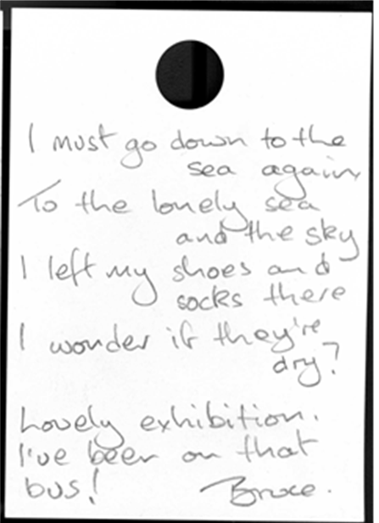
Example of creative writing from the post-its board.

Evaluation by the community creators’ group
Positive Outcome Wheels were devised to capture the individual participant’s journey. They were asked to score themselves on various criteria including;
- Level of confidence
- Skills learnt
- Making a difference to community
- Having fun
- Motivation, decision making and responsibility levels
- Feeling healthier – mind, body, spirit
- Feeling of fulfilment
- Meeting new people
These were completed at the start, half way through and at the final evaluation session.

This helped gain an understanding of what people wanted to get out of the project
and whether this was achieved over the course of the project. This highlighted how
things had changed for them, eg in terms of skills.

In the last session, the group was asked to reflect on how their experiences had ebbed and flowed over the lifespan of the project, with highs and lows shown in the Outcome wheel shapes at different points. Everyone felt that they had progressed and grown in different ways and learned new things.

Some members of the group showed some indicators decreasing towards the middle of the project, where there had been some feeling of dissatisfaction when some of the art works selected were not available.

Common themes in the positive outcomes for the individuals were:
- Learning new skills
- Making new friends
- Building confidence
- Fulfilment
- Contribution to the community
The detailed feedback from people’s outcome wheels is presented in Appendix 1.

The following diagram and comments by one of the group sums up their experience well – it is typical of most of the group’s individual outcome wheels, as illustrated by the table in Appendix 1.

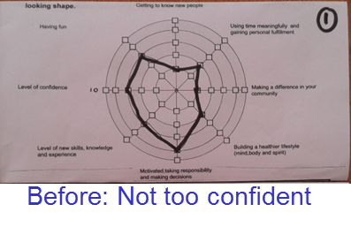
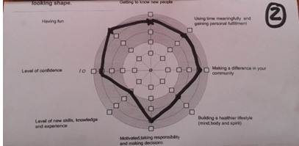
Middle: much more confident
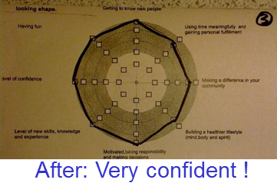

Group learning and reflections
At the final evaluation session, the group as a whole were also asked to reflect on their role as Community Curators. They discussed the challenges and pitfalls they faced in putting on the exhibition, and the opportunities and solutions they discovered along the way. The main issues identified are as follows:

- Group Decision making process – Within the group there were strong personalities, and the group learnt to work together. It was a challenge to accept choices not agreed with. There was individual disappointment when pieces selected were then rejected by the group. The group overcame this through their commitment and determination to achieve their shared goal of putting on the exhibition. Membership throughout the project was constant. Good team work, negotiation and interpersonal skills were demonstrated by all, despite the challenges and frustrations final decisions were reached with consensus.

- Learning about interpretation - The group embraced the process of interpretation with imagination, creativity and thoughtfulness. The creative sessions and filming were greatly enjoyed by the group. The filming gave them the opportunity to share their experiences in a personal way with the audience and connect to where they lived in West Hove and Portslade.

- Creative response- The art sessions were a relaxed and creative time that contributed to the group evolving and working well together. The group enjoyed seeing their own artwork displayed in the exhibition.

- Building new skills and confidence – The project broadened the groups’ horizons and exposed them to recognising and analysing artists and artwork they might otherwise never have seen. The group appreciated the opportunity to learn new skills and build confidence; many are now keen to get involved in further projects as a result. Being given the opportunity to do guided tours meant the group were able to get personal reactions and comments from the audience. Seeing the actual paintings on the wall, the true size, details and colours including impasto effect ( 3D paint ) was a pleasant surprise having selected the work from very small 2 D pictures of the pieces.

“I gained new skills and built confidence, I am ready for another project” Community Curator

Recommendations for future community curating projects
- Facilitating group dynamics - During the process of the project, strong personalities learned to work together, listen to and respect each other, facilitated by the TDC community development worker and RPM community engagement worker. The group enjoyed getting to know each other and making new friends. Some have made long lasting friendships and plan to go forward and work on new projects together. Future projects should also ensure they give sufficient support to facilitating group dynamics.
“I was not sure at the beginning about getting involved as I am not very good at voicing my opinion in groups, but I have got much better at it! I have enjoyed meeting new people and learning new things.” (Community Curator)

- Arts Council Collection accessibility The group expressed frustration at issues involved in using a collection which can only be researched online and via publications. They responded well to the challenge. The group recommended that the website design be improved as it is difficult to navigate, not all works include images, the search is dependent on knowing artists and their work, it can not be searched by themes The thumb nail images of the art could be enlarged to make them easier to find.

- It is important that the group understands the parameters of the selection of art at the outset. There was disappointment when the group had been through the process of selecting pieces to then find they could not have some of the pieces, due to their unavailability. It is important to manage expectations, to make groups aware of uncertainties.

- Local artists The group would have liked to have been able to include local Portslade artists, however the project brief was already defined, to select work to exhibit from the Arts Council Collection. They suggested some flexibility with the project guidelines in future to enable local artists to be exhibited alongside Arts Council Collection artists.

- Accessibility of the exhibition The exhibition was free to members of the public which the group felt would also be very important in future projects. It also raised the profile of West Hove and Portslade to the rest of Brighton and Hove.

- Involvement in every stage On reflection, the group would have liked to have been more involved in the hanging stage of the installation, so they could be part of the positioning of art pieces at the final stages, and have a say in decisions on the gallery décor eg the colour of the walls. It was acknowledged that this was due to the project and exhibition scheduling, the choice to include creative sessions, which weren’t part of the original project plan had also taken up project time and budget. Future projects could include group members in defined roles working in smaller groups on specific areas.

- Creative sessions The creative sessions and film making brought learning about interpretation alive. The resulting films, artwork and stories filled the galleries with different ways of looking at, and responding to, the artworks from the Arts Council Collection. The group were able to create a meaningful dialogue with visitors using their own words. Creative sessions should be a key part of future projects.
In summary, community curators said about the project:
“A unique experience !
We’ve seen art which we would otherwise have never seen,
Learnt to look at exhibitions with an even more critical eye.
A great sense of local community – everyone was proud to promote West Hove and Portslade.
Very keen to promote more art locally”

Follow up
The exhibition was promoted locally on community websites and talked about at public community meetings by group members, with the support of TDC. The opening of the Portslade Town Hall was a good chance to share it with local Portslade and also nearby West Hove residents. It was great to hear people saying they had visited the exhibition and were pleased at how it ‘put Portslade on the map’. They felt proud of where they lived. Community curators involved in the exhibition are continuing to work together, making plans to use their skills to put on a local art exhibition, supported by TDC and RPM.
Conclusion
This project has been a great opportunity for the RPM, TDC and residents to work collaboratively, actively engaging with the community. Over the year, the connections developed and evolved, and the group grew into a strong, committed team.

The group were given a very challenging and open brief to select an exhibition from the Arts Council Collection. They approached this with enthusiasm and perseverance. The project was a learning curve for us all, with the open nature of the brief being both an opportunity and a challenge.

The group were keen to understand the process of exhibition curation and interpretation. They expressed frustration at issues involved in using the Arts Council Collection which can only be researched online and via publications.

This diverse group of people responded well to the challenges, negotiating the world of curation and worked as a group to create a show that related to their own lives, between the Downs and the sea. They brought to the Museum their unique voices, experiences and priorities, including a strong focus on connecting and sharing. Film was chosen by the group as a medium to enhance the experience of the visitors: talking labels that are accessible to all.

The group embraced the process of interpretation with imagination, creativity and thoughtfulness. The resulting films, artwork and stories filled the galleries with different ways of looking at, and responding to, the artworks from the Arts Council Collection. Their desire to create a meaningful dialogue with visitors was also reflected in the opportunities the exhibition offered for others to leave their own comments and voices, and in the activities and tours they offered for Museums at Night and the Family Day.

So often in a Gallery or Museum the curators are anonymous. This exhibition personalised the selection adding new layers and ways in, empowering both the community curators and the visitors.

Evaluation report written by:
Joanna Hill and Clare Hopkins,The Trust for Developing Communities
Helen Grundy and Susan Eskdale, The Royal Pavilion, Libraries and Museums
And thanks to Adam Pride’s presentation slides at the TDC AGM

Thanks to
The Community Curators group:
Adam Pride; Saskia Wesnigk; Dorothy Martin; Carol Nicolaou; Robin Hurst; Fran Whittington; Angie Pride; Terry Hart; Linda Loveday.

January 2015

Printed and Published by The Trust for Developing Communities, Wavertree House, Somerhill Road, Hove BN3 1RN. Registered Charity 1106623. Jan 2015

