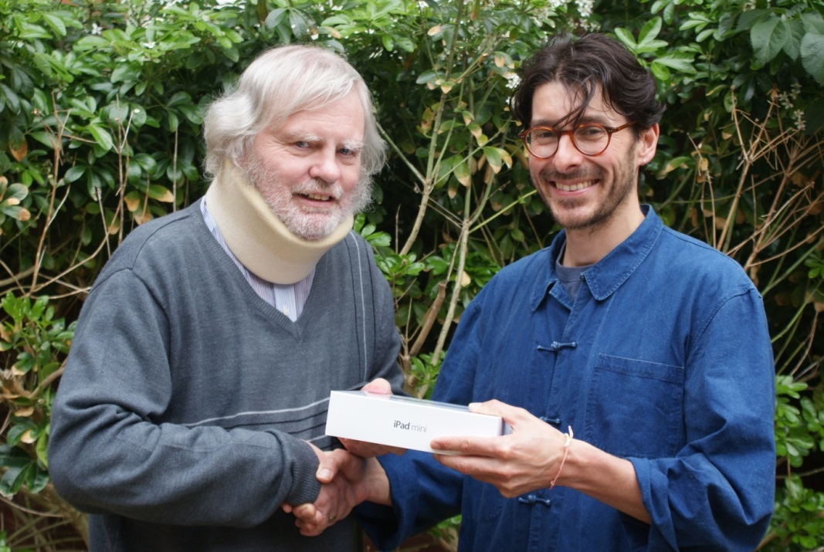
Above: Robert Brown (MBE) presents an iPad to Manu Fruteau (right)
The Trust for Developing Communities’ new website competition winner is also local voluntary sector worker.
The Trust for Developing Communities was very pleased to present local East Brighton resident Manu Fruteau with an iPad (donated by Spellman Electronics Ltd) after he entered the competition to launch their new website. TDC launched their new website in April 2014, after a year of consultation and work on communications and branding. TDC are very grateful for funding from Sussex Community Foundation and the Rotary Club Hove, who between them provided the £1,250 needed for the project to update their logo and have a new website built. Chair of Trustees, Robert Brown MBE, said “This has been a very successful process because we have involved our membership, Trustees, staff and volunteers at every level. We know how important it is that people can easily access our site for information and get what they need out of it. Not forgetting that there are also people who are not online, we must also grow with the new technology and increased use of social media.”
The competition attracted just under 200 entries and asked for the number of young people’s videos on the site which had been entered into the Big Dish Out 2014 for funding. Having answered correctly, Manu was then randomly picked as the winner and revealed that he also works for Sussex Interpreting Service, based in Community Base in central Brighton. Robert presented Manu with the iPad, saying “We like to have local people involved in local things and this has been a successful way to launch our new site”. Manu, who has worked for SIS in their IT and communications for 10 years, said “This is great! I will really enjoy using it and it will also come in handy at work for a bit of web design and web testing.” Linda Saltwell, the new Chief Executive at TDC said “We are really pleased that our new website has had more visitors as a result of this competition and that a partner organisation in the voluntary sector will benefit from the prize. It is serendipitous that Manu has won an iPad in our website launch competition that he intends to partly use for website design at his own organisation!”

